INDUSTRIAL QUANTUM ROBOT

Week - 1

**Name: KAVIN KISHORE S G**

**Roll: 7376221CS191**

1. **Installation of Ubuntu and working:**

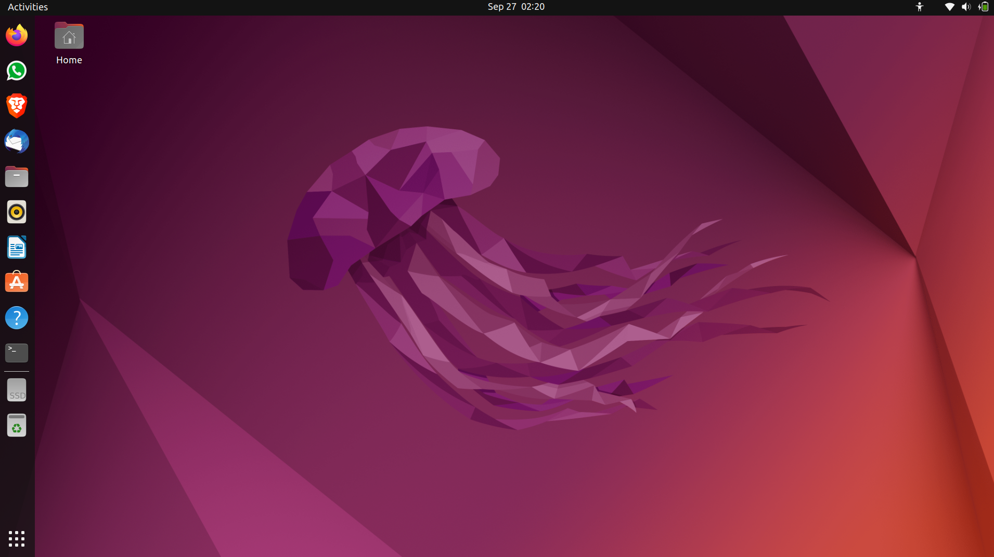

1. **QT installation and working:**

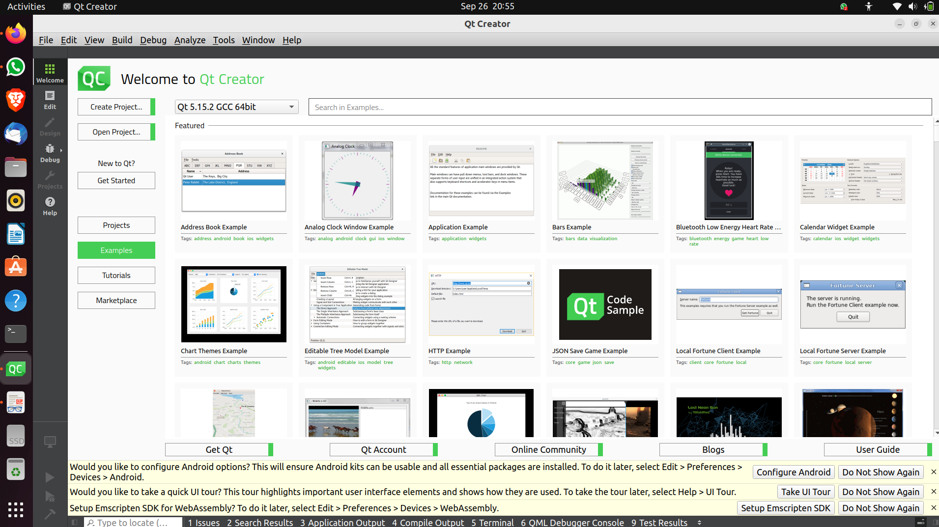

1. Installing OpenGL:

